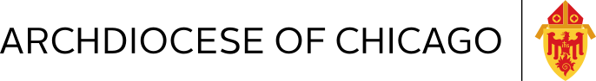
January 2023
Dear Parishioners of Our Lady of the Rosary,
I am writing today to share that the Archdiocese of Chicago has decided to merge the school communities of St. Bartholomew and Pope Francis Global Academy (PFGA). The new, merged school will be housed at the PFGA campus and retain the PFGA name.
Ms. Nilma Osiecki, currently the principal at St. Bartholomew, will serve as the principal of the unified PFGA beginning July 1, 2023. She will continue to serve as the principal of St. Bartholomew for the remainder of this school year.
These decisions come as the result of much consideration of the students of both St. Bartholomew and PFGA. One of the greatest indicators of school success is robust enrollment. The recent enrollment struggles of both St. Bartholomew and PFGA have resulted in financial strain that limits program offerings and facilities investment which are critical to an excellent student experience. Uniting these two student bodies on one campus will stabilize financials and couple resources to offer academic and extracurricular opportunities that the individual schools could not offer on their own.
Although difficult, I believe this merger will result in a robust, vibrant school that can provide an excellent, faith-based education for every student.
Sadly, this merger means that students will no longer gather in St. Bartholomew school building. In 1921, four Sisters of St. Dominic opened the doors to the very first students and ignited a tradition that would last 101 years. My prayer is that the rich history and wonderful story of St. Bartholomew school will continue to live on through the current students and the scores of alumni who remain dear friends.
We will keep you informed of plans for upcoming events to pray for our students and to toast St. Bartholomew School in the hopes you will join us. We also know that you will be concerned about the next life for our dear old building. Those plans will be made by local leadership and the Archdiocese in the next year.

Peace,

Greg Richmond
Superintendent
Archdiocese of Chicago Catholic Schools

